USER GUIDE  
PETBot Company

1. **Overview**- This website contains Home, Product chart, Contact Us, Register, Login, Site map, Category (Food and beverage, Pharmaceutical, Healthcare, Industry, Honey), Quick Order, Our catalogue, Feedback, Our Gallery.  
   - Before you begin, please make sure that you have a working internet connection.  
   - Click on Home.html locate inside the folder Source Code file to get start
2. Instruction

This section contains some instruction on how to navigate the website:  
1. Company name- Company name lives on the top center of the page. This is PETBot Company.  
2. Navigation bar- Navigation bar contain information about all the main pages of the website, locate below the company name, right column and left column.  
- To go to a particular page, click on the page name in the navigation bar:  
- To go to home page, please click on HOME

- To go to Product chart, please click on PRODUCT  
- To go to Contact us page, please click on CONTACT US

- To go to Register page, please click on REGISTER

- To go to login page, please click on LOGIN

- To go to Site Map, please click on SITE MAP

- To go to Order, please click on Quick Order (right column)

- To go to see our Catalogue, please click on Our Catalogue (right column)

- To go to send feedback, please click on Feedback (right column)

- To go to see our gallery, please click on Gallery (right column)  
- To go to Food bottle or Food jars, please hover on Food and Beverage, there will be a drop-down options for you to choose Food bottle or Food jars. (left column)

- To go to Pharmaceutical, please click on Pharmaceutical (left column)

- To go to Healthcare bottle or Healthcare jars, please hover on Healthcare, there will be a drop-down options for you to choose Healthcare bottle or Healthcare jars. (left column)

- To go to Industry, please click on Industry (left column)

- To go to Honey, please click on Honey (left column)  
III. Information about the Web pagesThis section contains information about each page in the website

1. **Homepage:**

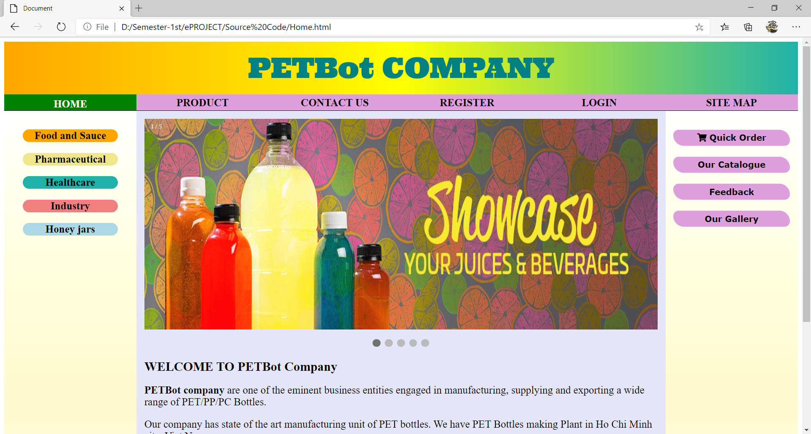

**Description** : Home page: Company introduction and carousel.

**From** : Home navigation bar

**To** : Product, Contact Us, Register, Login, Site Map, Category, Our Gallery, Our Catalogue, Quick Order, Feedback.

1. **Product:**

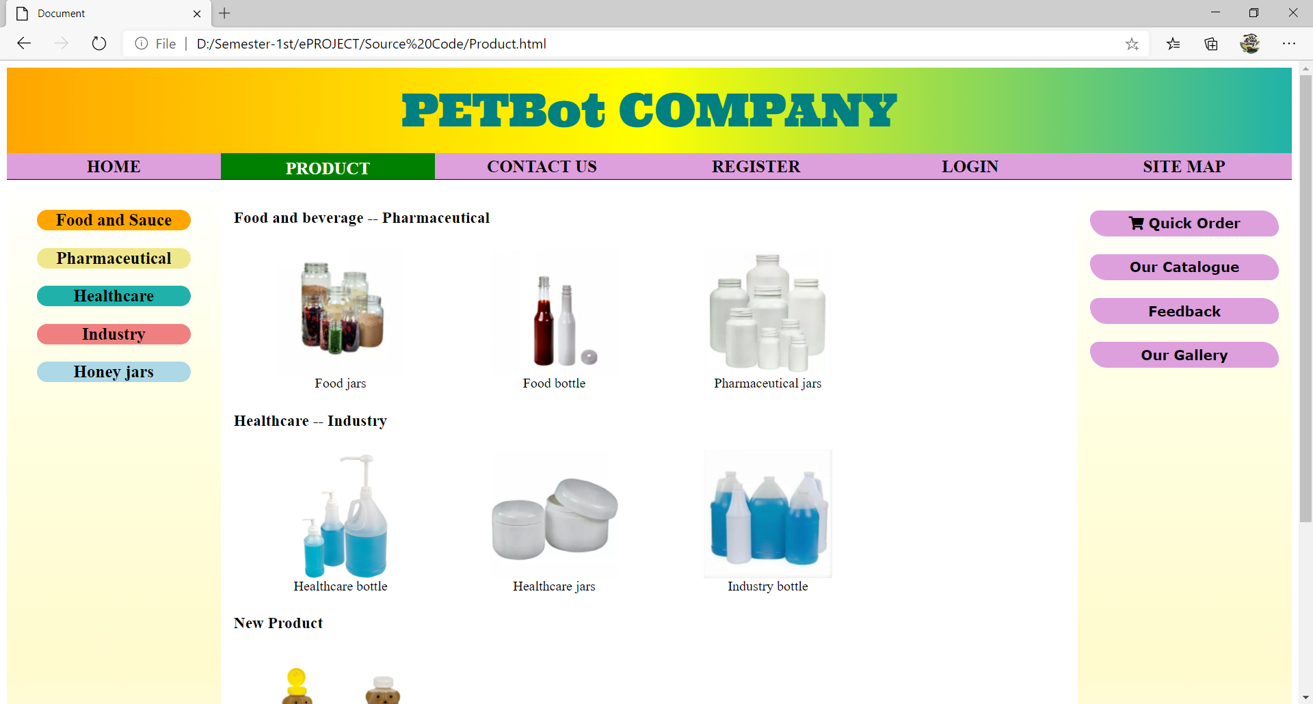

**Description** : Product: You can see product chart and go to the wanted product page by click the picture of this product.

**From** : Home / Our Product navigation bar

**To** : Home, Contact Us, Register, Login, Site Map, Category, Our Gallery, Our Catalogue, Quick Order, Feedback.

1. **SITE MAP:**

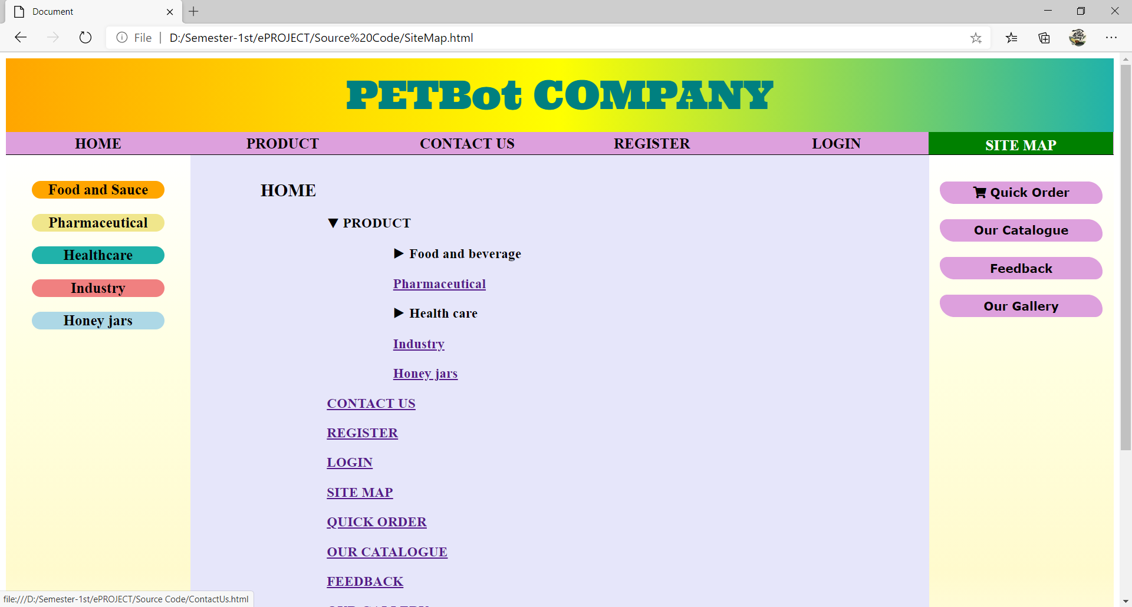

**Description** : Site Map: you can see site map and go directly the wanted page by click the name page in the site map

**From** : Home / Site Map navigation bar

**To** : Home, Contact Us, Register, Login, Product, Category, Our Gallery, Our Catalogue, Quick Order, Feedback.

1. **Gallery:**

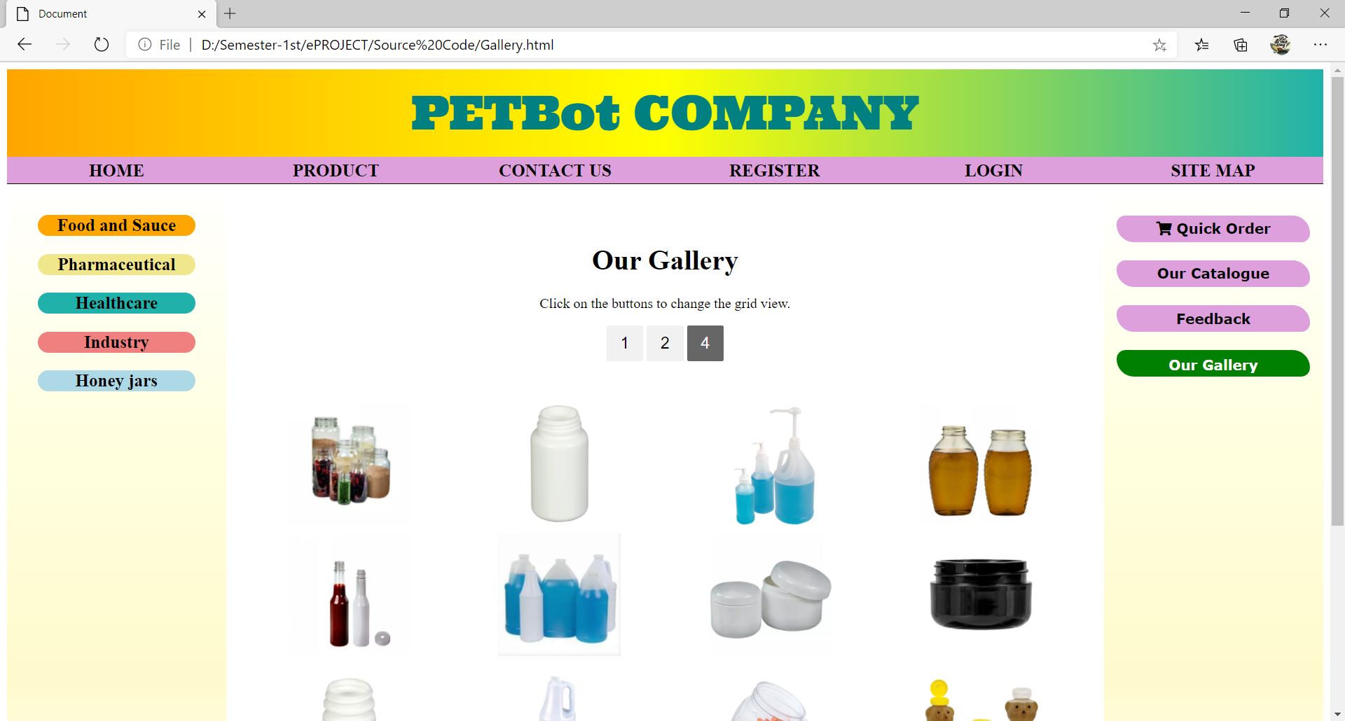

**Description** : Gallery: hover product picture, you can see the tittle of category of product that can help you find product easily by category.

**From** : Home / Gallery navigation bar

**To** : Home, Contact Us, Register, Login, Our Product, Category, Site Map, Our Catalogue, Quick Order, Feedback.

1. **CATEGORY:**

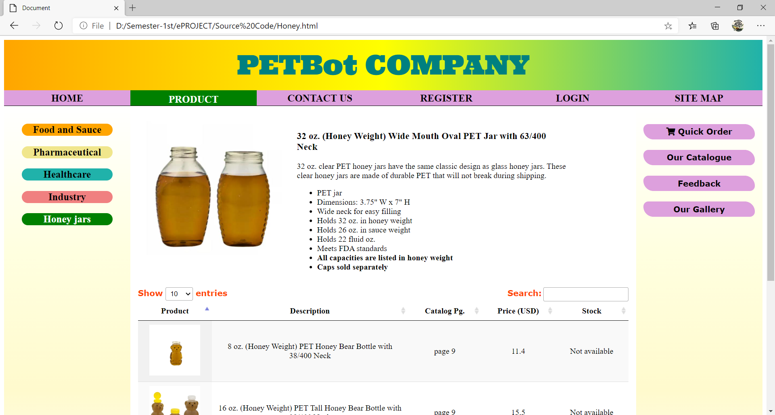

**Description** : Category left column: Pharmaceutical/Food bottle/Food jars/Industry/Healthcare bottle/Healthcare jars/Industry/Honey jars

**From** : Home / Product navigation bar / Category (…)

**To** : Home, Contact Us, Register, Login, Site Map, Category, Our Gallery, Our Catalogue, Quick Order, Feedback.

1. **CONTACT US**

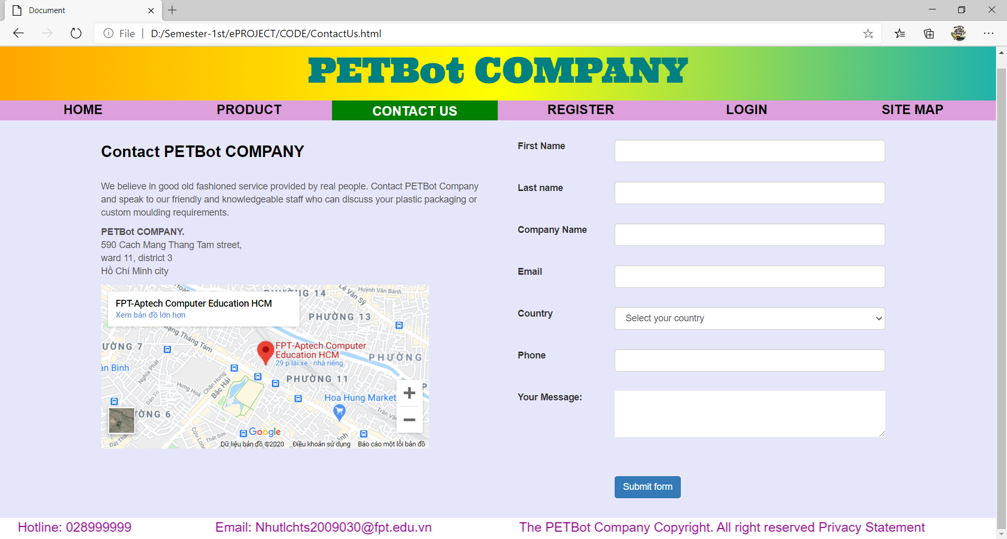

**Description** : Contact Us: Contact form and Geolocation. You should enter you information (such as first name, last name, email, country, phone and your message)

**From** : Home / Contact Us navigation bar

**To** : Home, Product, Register, Login, Site Map

1. **REGISTER**

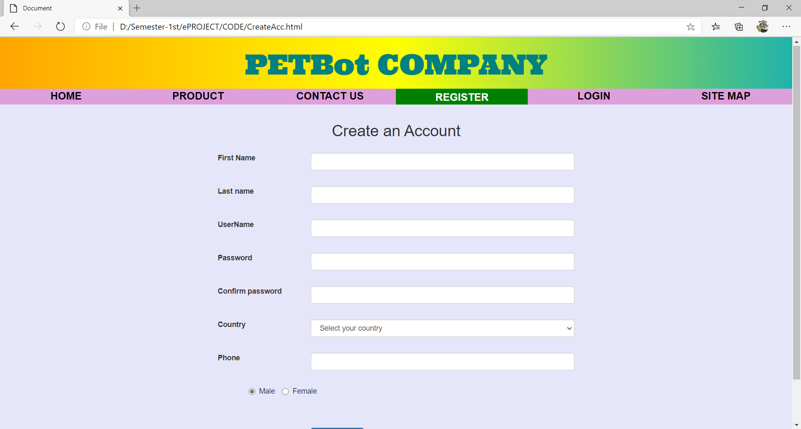

**Description** : Register : Register form to create new account

**From** : Home / Register navigation bar

**To** : Home, Product, Contact Us, Login, Register, Site Map,

1. **LOGIN:**

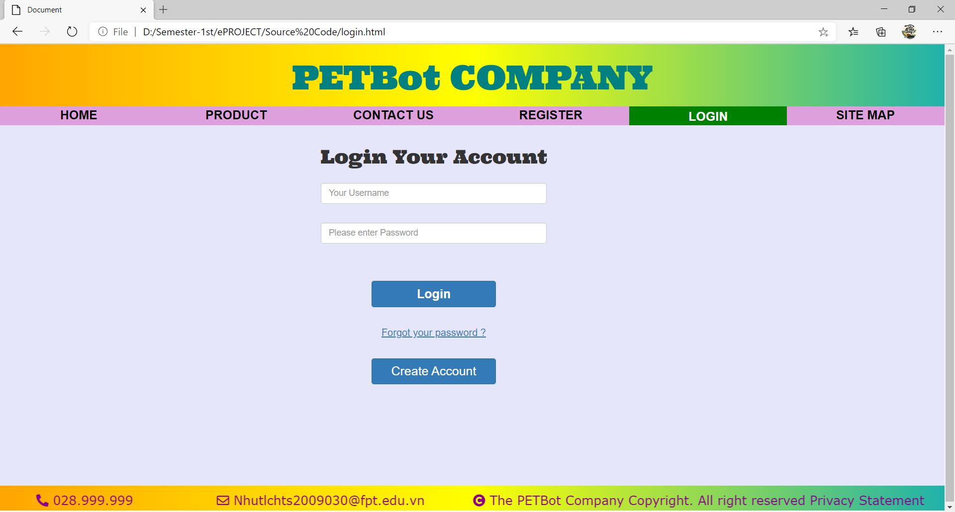

**Description** : Login : Login your account form

**From** : Home / Login navigation bar

**To** : Home, Our Product, Contact Us, Login, Register, Site Map,

1. **Quick Order:**

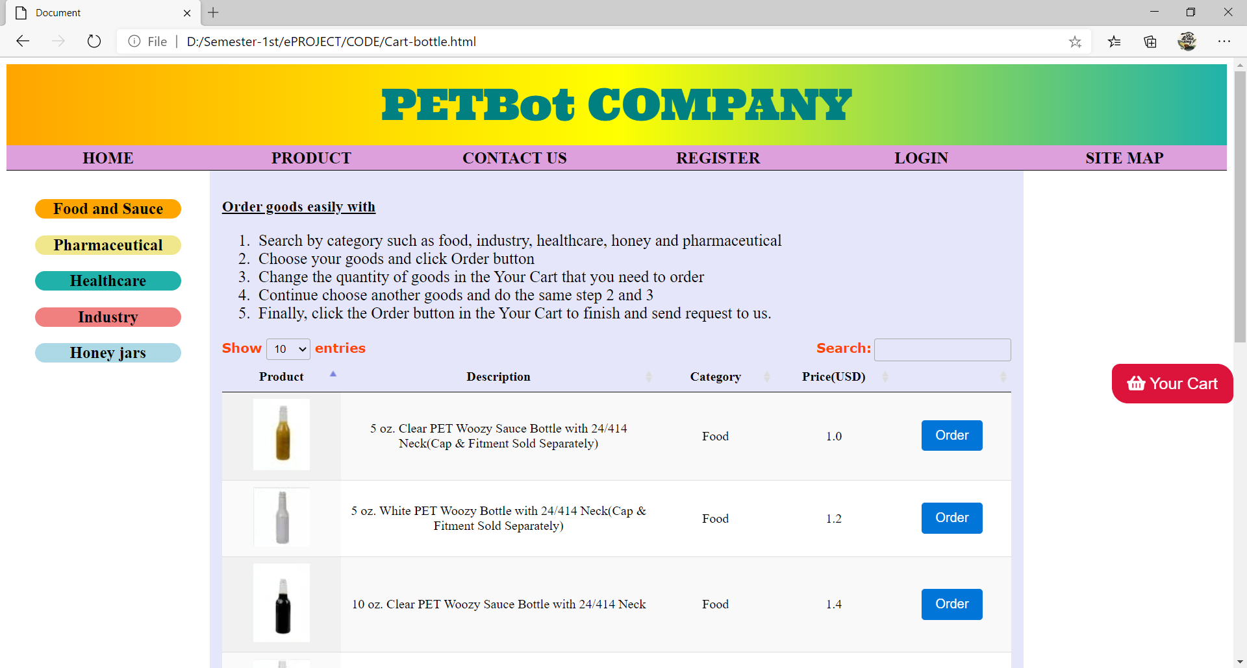

**Description** : Quick Order : Cart and list of all product with description, category, price and order button

**From** : Home / Quick Order navigation bar

**To** : Home, Our Product, Contact Us, Login, Register, Site Map, Category,

1. **Our Catalogue:**

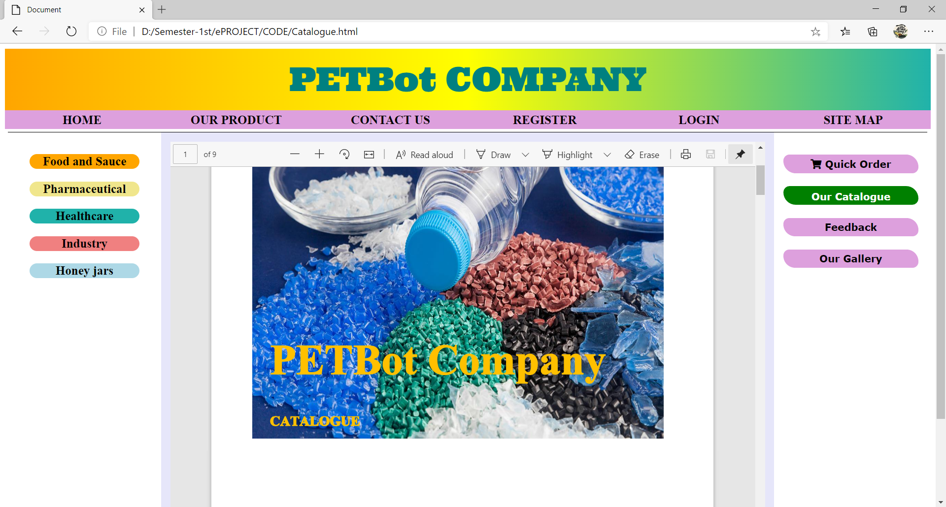

**Description** : Our Catalogue : Catalogue.pdf

**From** : Home / Our catalogue navigation bar

**To** : Home, Our Product, Contact Us, Login, Register, Site Map, Category,

Quick Order, Feedback, Our Gallery.